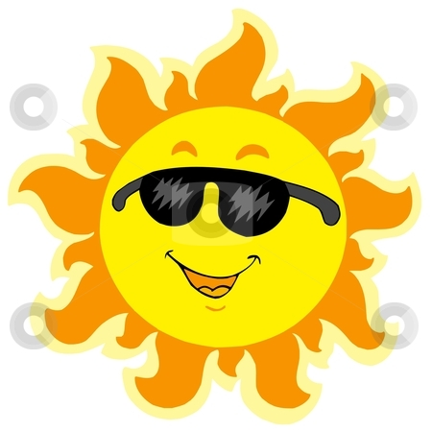English I and English I Pre-AP
2016 Reading Experience

In her book, Reading for Themselves, Deborah Appleman writes,
“Connections between our books and our worlds engage us and reassure us of the value of what we have learned, and these connections come only with years of reading. The recognition of cultural importance is crucial. It informs our decisions and it shapes our aspirations, but this kind of literacy does not come with mere exposure and memorization. It comes with deep experience…” (12).
Because we want every student to have these deep experiences with books, each summer the Westlake High School English Department assigns summer reading with the belief that reading good literature provides enjoyment, develops insight into human behavior, promotes language development, fosters good writing, educates the mind and imagination, and allows readers to discover new ideas.
Our department also recognizes the importance of choice in creating these deep experiences. As Mike Anderson writes in his book Learning to Choose, Choosing to Learn,
“When students have more choice about their learning, they can find both ways of learning that match their personal needs and engage with work more powerfully, building skills, and work habits that will serve them well as lifelong learners” (3).
As you make your choices about summer reading, use the specific criteria selected for your grade level and course. You will find this criteria on the back of this handout. In addition, please try to read as much as possible and keep track of the things you read in some way. Are you reading blogs, magazines, fictional books, newspapers, poems, non-fiction books, essays, or other? As you read, here are a few ideas to consider.
Over the summer….
1. the funniest thing I read…
2. the most shocking thing I read…
3. the most inspirational thing I read…
4. the most entertaining thing I read…
5. the most challenging thing I read…
6. the most captivating thing I read…
7. the most thought-provoking thing I read…
8. the best page-turner I read…
9. the most romantic/suspenseful/confusing thing I read…
10. the most encouraging/annoying/outrageous thing I read…

And why read? The International Reading (now Literacy) Association pointed out in their 1999 position statement on Adolescent Literacy (and reiterated in the 2012 update of this statement): “Adolescents entering the adult world in the 21st century will read and write more than at any other time in human history. They will need advanced levels of literacy to perform their jobs, run their households, act as citizens, and conduct their personal lives. They will need literacy to cope with the flood of information they will find everywhere they turn. They will need literacy to feed their imaginations so they can create the world of the future. In a complex and sometimes even dangerous world, their ability to read can be crucial” (4).
Happy Reading!!

Book Selection:
English I English I Pre-AP
Genre Young Adult Fiction Young Adult Fiction
Minimum Page Length 150+ pages 250+ pages
Written after 2002 Yes Yes
Previously Read No No
Graphic Novels No No
Upon returning to school in August, students will share their summer reading experience. While reading, you should note significant moments, character development, author’s message and whether or not you would recommend this book to others.
Please find below a list of summer reading possibilities. Note that you are not obligated to make a selection from this list.
- Marcelo in the Real World by Francisco Stork
- Ship Breaker by Paolo Bacigalupi
- Unwind by Neal Shusterman
- Brain Jack by Brian Falkner
- Shift by Jennifer Bradbury
- Dear Zoe by Philip Beard
- Going, Going, Gone by Naomi Shihab Nye
- A Northern Light by Jennifer Donnelly
- Leviathan by Scott Westerfeld
- Born at Midnight by C.C. Hunter
- Cinder by Marissa Meyer
- Thirteen Reasons Why by Jay Asher
- An Abundance of Katherines by John Green
- Uglies by Scott Westerfeld
- Looking for Alaska by John Green
- Mockingbird by Kathryn Erskine
- Monster by Walter Dean Myers
Additional Information:
You might want to consider going online and visiting the Young Adult Library Service Association (YALSA) website, Goodreads.com, iTunes and Amazon.com for reviews, ratings and information that will assist you in your summer reading selection.
If you have any questions about the summer reading assignment, please contact Valerie Taylor, Instructional Partner for Humanities, at vtaylor@eanesisd.net.

